**SONIC SENTINEL: IOT-BASED EXTREME SOUND ALERT SYSTEM**

# A Minor Project work

*Submitted in partial fulfilment of the Requirements for the Award degree of*

**Bachelor of Technology**

# In

**Electronics & Communications Engineering**

Submitted by

Kovilala Rohith 211114210

Peddoju Tejopaul 211114237

Yalla Rahul 211114254

Pagilla Pavan 211114257

Tangudu Arun 211114277

# Under the guidance of

**Dr.Dheeraj K. Agarwal**

# APRIL - 2024

**ELECTRONICS & COMMUNICATION ENGINEERING DEPARTMENT MAULANA AZAD NATIONAL INSTITUTE OF TECHNOLOGY, BHOPAL**



# MAULANA AZAD NATIONAL INSTITUTE OF TECHNOLOGY,

**BHOPAL**

**DECLARATION BY CANDIDATES**

We hereby declare that the Report of the Minor Project Work entitled “Sonic Sentinel: IoT-Based Extreme Sound Alert System” which is being submitted to the **Electronics & Communication Engineering Department, MANIT BHOPAL**, in the partial fulfilment of the requirements for the award of the degree of **Bachelor of Engineering** in **the Department of Electronics & Communication Engineering**, is a bonafied report of the work carried out by us. The material contained in this report has not been submitted to any University or Institution for the award of any degree.

|  |  |  |  |
| --- | --- | --- | --- |
| **S.No.** | **Scholar No.** | **Name of Students** | **Signature of students** |
| 1 | 211114210 | Kovilala Rohith |  |
| 2 | 211114237 | Peddoju Tejopaul |  |
| 3 | 211114254 | Yalla Rahul |  |
| 4 | 211114257 | Pagilla Pavan |  |
| 5 | 211114277 | Tangudu Arun |  |

**CERTIFICATE OF APPROVAL**

It is certified that the work contained in this report titled “Sonic Sentinel: IoT-Based Extreme Sound Alert System” is the original work done by the students and has been carried out under my supervision.

**(Signature of guide)**

**GUIDE NAME: Dr. Dheeraj K. Agarwal**

**Date**

**ABSTRACT**

This project presents an advanced solution for real-time sound monitoring and notification using the KY037 sound sensor, ESP8266 WiFi module, and Blynk application platform. Sound levels are continuously monitored in the environment, with the system capable of visualizing data in the Blynk app interface in real-time. A pivotal feature of this system is its configurable maximum sound threshold, enabling users to define critical levels for triggering notifications and email alerts. The integration of hardware components with the Blynk platform ensures seamless data transmission and remote access, empowering users with insights into sound dynamics and facilitating proactive decision-making.

The project's implementation emphasizes the significance of sound monitoring across various domains, including home security, industrial safety, and environmental conservation. By providing users with a comprehensive solution for sound detection and analysis, the system addresses the need for effective acoustic surveillance in today's dynamic environments. Through its intuitive interface and customizable alerting mechanism, the project offers a versatile tool for enhancing situational awareness and mitigating potential risks associated with excessive noise levels.

Furthermore, the project underscores the potential applications of real-time sound monitoring in urban planning, public health, and infrastructure management. By leveraging the capabilities of the KY037 sensor, ESP8266 module, and Blynk platform, the system facilitates data-driven decision-making in sound-sensitive contexts. Whether deployed in residential settings to detect intrusions or in industrial environments to ensure compliance with noise regulations, the proposed solution offers a scalable and adaptable framework for monitoring and managing sound levels effectively.

Moreover, this project contributes to the burgeoning field of Internet of Things (IoT) applications by showcasing a practical implementation of sensor integration with wireless communication and cloud-based visualization. By harnessing the power of ESP8266 WiFi module and Blynk's versatile platform, the system provides a scalable framework for extending its functionality to incorporate additional sensors and features. This modular approach not only enhances the system's flexibility but also opens up avenues for future enhancements and integrations, facilitating continuous innovation in the realm of sound monitoring and smart sensing technologies. Overall, this project serves as a testament to the transformative potential of IoT solutions in addressing real-world challenges and advancing towards a more connected and informed society.

Top of Form

**ACKNOWLEDGEMENT**

We would like to acknowledge the support provided by **DR. DHEERAJ K. AGARWAL** in guiding and correcting us at all stages of development of this project with utmost attention and care. We express our thanks to **Dr. R.N. Yadav**, Head of the Department Electronics and Communication Engineering, for extending his support and providing us necessary facilities. We would in particular give our regards to our guide, **Dr. DHEERAJ K. AGARWAL**, for his insightful advice, invaluable guidance, help, support in successful completion of this project and his consistent encouragement, advices throughout our project work. It was a great learning experience for us and we sincerely thank you for giving us this opportunity.

Sincerely,

Kovilala Rohith (211114210)

Peddoju Tejopaul (211114237)

Yalla Rahul (211114254)

Pagilla Pavan (211114257)

Tangudu Arun (211114277)

# TABLE OF CONTENTS

**TITLE PAGE**

**DECLARATION BY CANDIDATES AND CERTIFICATE**

**ABSTRACT…………………………………….................i**

**ACKNOWLEDGEMENTS………………….…..............ii**

**TABLE OF CONTENTS…………………...…..........….iii**

**LIST OF FIGURES…………………………...................iv**

**LIST OF TABLES…………………………..…...........….v**

**LIST OF SYMBOLS AND ABBREVIATIONS…........vi**

**1.INTRODUCTION…………………………...................1**

**2. LITERATURE SURVEY………………………...........2**

2.1 Blynk App Connectivity………….…............……2

2.2 Old methods………………………..........….…….2

2.3 New Methods….............….........................….…...3

2.4 Our Method………………….......................……..3

**3. METHODOLOGY…………………………................…..4**

3.1 Software Used.............................................................4

3.1.1 Arduino IDE ......................................................4

3.2 Components..................................................................4

3.2.1 ESP 8266............................................................5

3.2.2 KY037............................................................... 5

3.3 Working........................................................................6

3.3.1 Sound detection................................................. 6

3.3.2 Data Transfer..................................................... 7

3.3.3 Data Processing..................................................7

3.3.4 Circuit Diagram................................................. 8

3.3.5 Block Diagram................................................... 8

**4.APPLICATIONS……………………………..………….9**

**5.REFERENCES……………………………………………..10**

# LIST OF FIGURES

**Name of Figure Page No.**

3.1 ESP 8266 5

3.2 KY 037 Pin Configuration 6

3.3 Circuit diagram 8

3.4 Block Diagram 8

**LIST OF TABLES**

# Name of Table Page No.

3.1 ESP8266 Module description . . . . . . . . . . . . . . . . . . . . 6

# LIST OF SYMBOLS AND ABBREVIATIONS

ESP - Event Stream Processing

IOT - Internet Of Things

dB - Decibels

# INTRODUCTION

In today's dynamic and interconnected world, the need for real-time monitoring and analysis of environmental parameters, such as sound levels, has become increasingly paramount. Whether it's ensuring workplace safety, maintaining residential tranquility, or adhering to noise regulations in public spaces, the ability to detect and respond to fluctuations in sound levels is essential. In response to this growing demand, our project aims to develop a comprehensive solution for real-time sound sensing and notification, leveraging the synergy of hardware components like the KY037 sound sensor and ESP8266 WiFi module, along with the versatile visualization capabilities of the Blynk application platform.

The integration of sound sensors with wireless communication technologies opens up a myriad of possibilities for remote monitoring and data-driven decision-making. By harnessing the power of the ESP8266 WiFi module, our system enables seamless transmission of sound data to the cloud, where it can be visualized, analyzed, and acted upon in real-time. This not only enhances situational awareness but also facilitates proactive responses to sound-related events, such as intrusions, equipment malfunctions, or environmental disturbances.

Furthermore, the adoption of the Blynk application platform adds a layer of accessibility and user-friendliness to our system. With its intuitive interface and customizable alerting mechanisms, Blynk empowers users to monitor sound levels remotely and receive timely notifications via their smartphones or email. This combination of hardware and software components not only enhances the efficiency and effectiveness of sound monitoring but also paves the way for future advancements and integrations in the field of Internet of Things (IoT) and smart sensing technologies.

# 2. LITERATURE SURVEY

**2.1 Blynk App Connectivity**

To establish a connection between the Blynk application and the ESP8266 WiFi module, the module is configured to connect to the local WiFi network, enabling communication with the Blynk server over the internet. Within the Blynk app, a project is created, and a unique authentication token is generated, serving as an identifier for the project. In the Arduino code running on the ESP8266, the Blynk library is included, and the authentication token is inserted to establish a connection with the Blynk server. Widgets in the Blynk app, linked to virtual pins defined in the code, allow for real-time visualization of sensor data and control of connected devices. This connection enables remote monitoring and control of the system from anywhere with an internet connection, providing a convenient solution for IoT applications.

**2.2 Old Methods**

In traditional methods predating advanced sensor technologies like the KY037 sound sensor, sound detection often relied on indirect measurements such as air pressure variations. These methods, commonly known as acoustic methods, utilized sensitive instruments to detect minute changes in air pressure caused by sound waves. One such method involved employing microphones or pressure transducers to convert acoustic signals into electrical signals for further processing. However, these approaches often posed challenges in terms of sensitivity, accuracy, and susceptibility to environmental interference.

Another approach to sound detection in the absence of modern sensors involved the use of mechanical devices such as sound level meters or decibel meters. These devices measured sound intensity by quantifying the physical displacement caused by sound waves. Typically, a microphone would pick up sound waves, which would then cause a diaphragm or other mechanical element to vibrate. The displacement of this element would be translated into a readable measurement of sound intensity, usually in decibels (dB).

**2.3 New Methods**

A new method for sound sensing involves the utilization of highly sensitive electronic sensors, such as the KY037 sound sensor, which can directly detect sound waves and convert them into electrical signals. These sensors leverage cutting-edge technology to offer enhanced sensitivity, accuracy, and versatility in sound detection. By incorporating features such as adjustable sensitivity and digital output, these sensors can adapt to various environments and sound levels, providing precise measurements in real-time. Furthermore, advancements in wireless communication protocols, exemplified by modules like the ESP8266, enable seamless integration with cloud-based platforms for remote monitoring and data visualization. This modern approach to sound sensing not only offers improved performance and reliability but also opens up new possibilities for applications in smart homes, industrial automation, and environmental monitoring. With its combination of advanced sensors and wireless connectivity, this method represents a significant leap forward in the field of sound detection, offering greater convenience, efficiency, and accessibility compared to traditional methods.

**2.4 Our Method**

In this project, we adopt a novel approach to sound sensing by leveraging the capabilities of the KY037 sound sensor integrated with the ESP8266 WiFi module. The KY037 sensor, equipped with a high-sensitivity microphone and onboard signal processing circuitry, enables direct and precise detection of sound waves in the environment. By interfacing this sensor with the ESP8266 module, we establish a wireless connection to the Blynk application platform, facilitating real-time data transmission and visualization. This method offers several advantages over traditional approaches, including enhanced sensitivity, adaptability, and remote accessibility. Additionally, the customizable threshold-based alerting mechanism implemented in the Blynk app allows for proactive notification and email alerts when sound levels exceed predefined thresholds. By harnessing the synergy of advanced sensor technology and wireless communication, this method provides a robust and efficient solution for sound monitoring and notification in various applications, from home security to industrial safety.

**3. METHODOLOGY**

**3.1 SOFTWARE REQUIREMENTS**

**3.1.1 Arduino IDE**

Arduino IDE served as the primary software tool for writing, compiling, uploading, and debugging the code that controls the behavior of the mouse. Using the IDE, developers wrote code to read data from the MPU6050 sensor, process motion and orientation data, and transmit it via Bluetooth using the HC-05 modules. After writing the code, it was compiled within the IDE to ensure its correctness and compatibility with the Arduino boards. Then, the compiled code was uploaded to the Arduino Nano and Pro Micro boards, which form the core of the air mouse system, allowing them to execute the programmed instructions.

**3.2 COMPONENTS REQUIRED**

**3.2.1 ESP 8266 (Wi-Fi module)**

The ESP8266 stands as a versatile cornerstone in the realm of IoT, boasting a plethora of functions tailored for seamless connectivity and control. With its built-in Wi-Fi capabilities, it facilitates effortless communication with wireless networks, enabling remote monitoring, data exchange, and integration with web services. Acting as a microcontroller, it executes tasks to control sensors and actuators, while its GPIO pins offer flexibility for interfacing with various peripherals. Supporting standard networking protocols, the ESP8266 enables internet communication, empowering developers to create sophisticated IoT solutions with ease and efficiency.

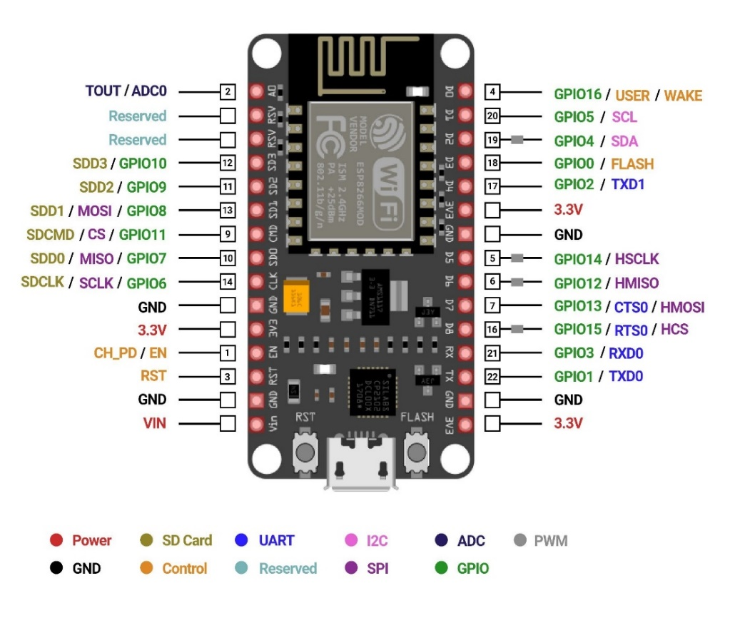

figure 3.1: ESP 8266

**3.2.2 KY-037 (Sound Sensor)**

The KY-037 Sound Sensor Module serves as a valuable component in electronics projects, primarily functioning to detect sound levels in its environment. Its key function lies in its ability to convert sound signals captured by its built-in electret microphone into electrical signals, providing a means for sound analysis and processing. This functionality makes it suitable for applications ranging from sound-activated switches to noise monitoring systems, enabling developers to integrate sound detection capabilities seamlessly into their projects. With its straightforward interface and compatibility with microcontrollers such as Arduino, the KY-038 facilitates the implementation of sound-based functionalities in various contexts with ease and precision**.**

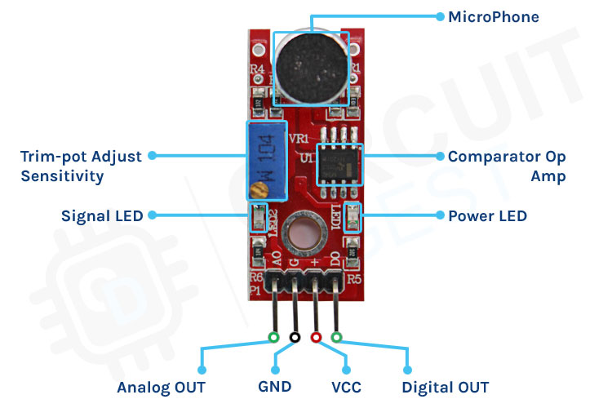

Figure 3.2: KY-037 pin configuration

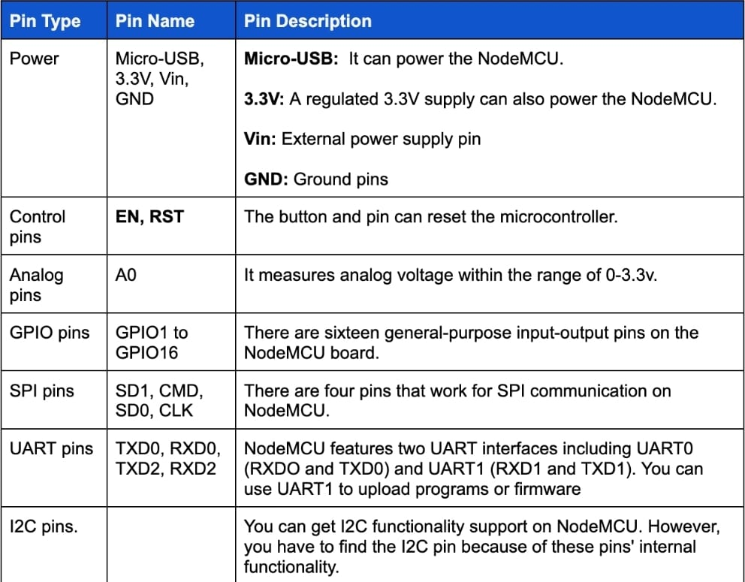

Table 3.1**: E**SP 8266 Module description

**3.3 WORKING:**

**3.3.1 Sound Detection:**

The KY037 sound sensor functions by utilizing a microphone element to detect sound waves, converting them into analog electrical signals proportional to sound intensity. These signals are then amplified for clarity and output through a pin. By interfacing with external circuitry or microcontrollers, the sensor enables the detection and analysis of sound levels, allowing for the implementation of threshold detection and triggering actions based on predefined sound thresholds.

**3.3.2 Data Transfer:**

Data transfer to the ESP8266 module typically occurs through a wireless connection established with a local WiFi network. The module is configured to connect to the WiFi network, enabling it to send and receive data packets over the internet. This data transfer can be achieved using protocols such as HTTP, MQTT, or TCP/IP, allowing the ESP8266 to communicate with external devices, servers, or cloud platforms. Once connected, the ESP8266 can receive commands or sensor data from remote sources and execute programmed actions accordingly, facilitating real-time monitoring, control, and automation in IoT applications.

**3.3.3 Data Processing:**

The WiFi module, such as the ESP8266, processes data received from sensors by interpreting signals and converting them into a format compatible with the Blynk platform. This involves encoding the data into packets and establishing a secure connection with the Blynk server over the internet. Once connected, the module transmits the data to the Blynk server, which then forwards it to the designated project in the Blynk app. Within the app, widgets are configured to receive data from specific virtual pins associated with the module.

As data is received, the widgets dynamically update, plotting the information in real-time on graphs, gauges, or other visualizations within the Blynk interface. This seamless integration between the WiFi module and Blynk platform enables users to remotely monitor and visualize sensor data, facilitating efficient decision-making and control in IoT applications.

**3.3.4 Circuit Diagram:** 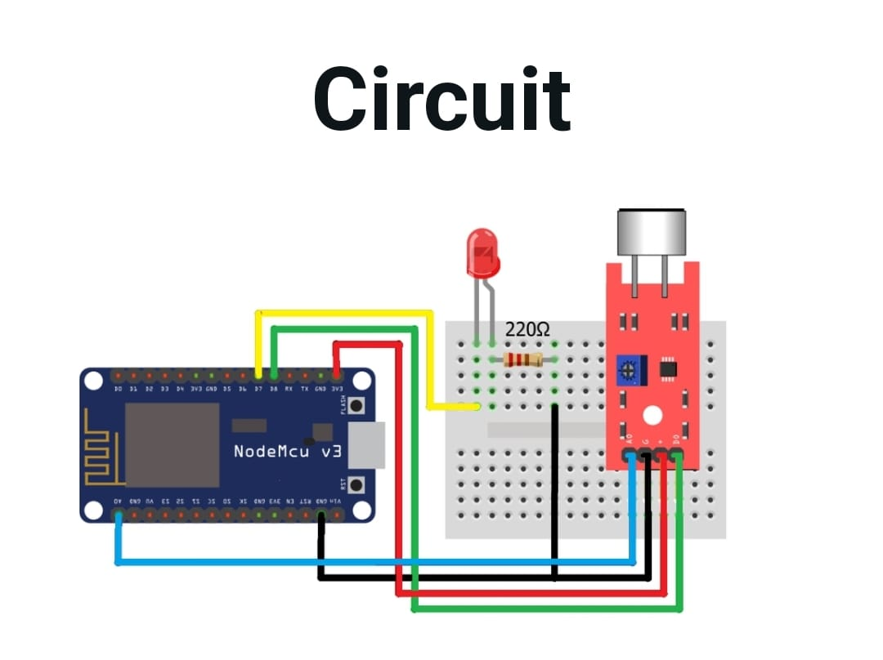

Figure 3.3: Circuit diagram

**3.3.5 Block Diagram:**

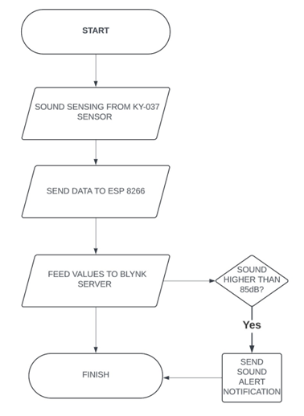

Figure 3.4: Block Diagram

**4. APPLICATIONS**

The applications of this project are diverse and encompass various domains where real-time sound monitoring and notification systems are essential. In residential settings, the system can serve as an effective tool for enhancing home security by detecting and alerting residents to suspicious sounds or potential intrusions. By setting thresholds for sound levels, homeowners can receive immediate notifications via the Blynk app and email alerts when unusual noise patterns are detected, enabling timely responses to security threats and ensuring peace of mind.

In industrial environments, the project finds utility in ensuring workplace safety and regulatory compliance by monitoring noise levels in factories, warehouses, and manufacturing facilities. Excessive noise exposure can pose significant health risks to workers and may indicate malfunctions in machinery or equipment. By integrating the sound sensing system with existing safety protocols, employers can proactively identify and address noise hazards, implement noise control measures, and prevent occupational hearing loss. Moreover, the system's ability to generate real-time alerts allows for prompt intervention in the event of equipment failures or hazardous noise levels, minimizing downtime and enhancing productivity.

Furthermore, the project has applications in environmental monitoring and urban planning, where the assessment of noise pollution levels is crucial for maintaining quality of life and public health. By deploying the sound sensing system in urban areas, city planners and policymakers can gather data on noise levels, identify high-risk areas, and develop strategies for mitigating noise pollution. This information can inform zoning regulations, transportation planning, and infrastructure development initiatives aimed at creating quieter and more livable cities. Additionally, by engaging citizens in sound monitoring efforts through the Blynk app, communities can raise awareness about the impacts of noise pollution and advocate for measures to address environmental noise concerns.

# REFERENCES

1. <https://how2electronics.com/iot-decibelmeter-sound-sensor-esp8266/>
2. <https://iotprojectsideas.com/iot-based-decibel-meter-with-esp8266-sound-sensor/>